**PIZZA SALES SQL QUERIES**

1. **Kpi’s**
2. **Total revenue**

select sum(quantity* unit_price) as "Total Revenue" from pizza_sales;

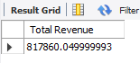

1. **Average order value**

select (sum(quantity* unit_price))/ count(distinct(order_id)) as 'Average order value' from pizza_sales;

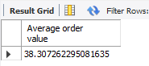

1. **Total pizza sold**

select sum(quantity) as 'Total pizza sold' from pizza_sales

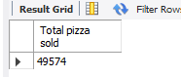

1. **Total number of orders**

select count(distinct(order_id)) as 'Total Number of orders' from pizza_sales;

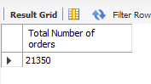

1. **Average pizza per order**

select round(sum(quantity)/count(distinct(order_id)),0) as 'Average pizza per order' from pizza_sales;

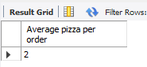

1. **Daily trend of the orders**

SET SQL_SAFE_UPDATES = 0;

UPDATE pizza_sales

SET order_date = STR_TO_DATE(order_date, '%d-%m-%Y')

WHERE STR_TO_DATE(order_date, '%d-%m-%Y') IS NOT NULL;

SET SQL_SAFE_UPDATES = 1;

-------------------------------------------------------------------------

SELECT

DAYNAME(left(order_date,10)) AS day_name, count(distinct(order_id)) as Total_orders

from pizza_sales

group by DAYNAME(left(order_date,10))

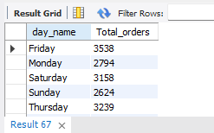

1. **monthly trend of the orders**

SELECT

monthname(order_date) AS month_name, count(distinct(order_id)) as Total_orders

from pizza_sales

group by month_name;

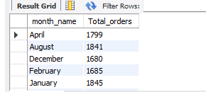

1. **percentage of sales by pizza category**

WITH tbl AS (

SELECT pizza_category, SUM(total_price) AS Total_per_category

FROM pizza_sales

GROUP BY pizza_category

),

tbl2 AS (

SELECT SUM(total_price) AS total

FROM pizza_sales

)

SELECT

tbl.pizza_category,

tbl.Total_per_category,

(tbl.Total_per_category / tbl2.total) * 100 AS percentage

FROM

tbl,

tbl2

ORDER BY

percentage DESC;

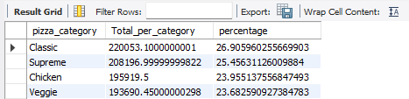

1. **percentage of sales by pizza size**

WITH tbl AS (

SELECT pizza_size, SUM(total_price) AS Total_per_size

FROM pizza_sales

GROUP BY pizza_size

),

tbl2 AS (

SELECT SUM(total_price) AS total

FROM pizza_sales

)

SELECT

tbl.pizza_size,

tbl.Total_per_size,

(tbl.Total_per_size / tbl2.total) * 100 AS percentage

FROM

tbl,

tbl2

ORDER BY

percentage DESC;

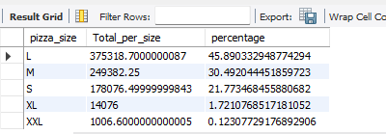

1. **top 5 pizza by revenue**

select

distinct(pizza_name),

sum(total_price) as Total_revenue,

(sum(total_price)/(select sum(total_price) from pizza_sales)*100) as percentage

from pizza_sales

group by (pizza_name)

order by percentage desc

limit 5

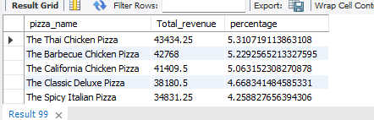

1. **bottom 5 pizza by revenue**

select

distinct(pizza_name),

sum(total_price) as Total_revenue,

(sum(total_price)/(select sum(total_price) from pizza_sales)*100) as percentage

from pizza_sales

group by (pizza_name)

order by percentage

limit 5

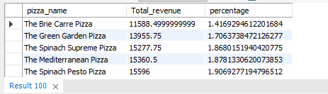

1. **top 5 pizza by quantity**

select

distinct(pizza_name),

sum(quantity) as Total_quantity,

(sum(quantity)/(select sum(quantity) from pizza_sales)*100) as percentage

from pizza_sales

group by (pizza_name)

order by percentage desc

limit 5;

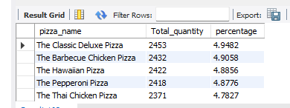

1. **bottom 5 pizza by quantity**

select

distinct(pizza_name),

sum(quantity) as Total_quantity,

(sum(quantity)/(select sum(quantity) from pizza_sales)*100) as percentage

from pizza_sales

group by (pizza_name)

order by percentage

limit 5;

